Question 1. HOW to Delete Duplicate Records in the table

Create the table

CREATE TABLE contacts (

id INT PRIMARY KEY AUTO_INCREMENT,

first_name VARCHAR(30) NOT NULL,

last_name VARCHAR(25) NOT NULL,

email VARCHAR(210) NOT NULL,

age VARCHAR(22) NOT NULL

);

Insert values into it

INSERT INTO contacts (first_name,last_name,email,age)

VALUES ('Kavin','Peterson','kavin.peterson@verizon.net','21'),

('Nick','Jonas','nick.jonas@me.com','18'),

('Peter','Heaven','peter.heaven@google.com','23'),

('Michal','Jackson','michal.jackson@aol.com','22'),

('Sean','Bean','sean.bean@yahoo.com','23'),

('Tom ','Baker','tom.baker@aol.com','20'),

('Ben','Barnes','ben.barnes@comcast.net','17'),

('Mischa ','Barton','mischa.barton@att.net','18'),

('Sean','Bean','sean.bean@yahoo.com','16'),

('Eliza','Bennett','eliza.bennett@yahoo.com','25'),

('Michal','Krane','michal.Krane@me.com','25'),

('Peter','Heaven','peter.heaven@google.com','20'),

('Brian','Blessed','brian.blessed@yahoo.com','20'),

('Kavin','Peterson','kavin.peterson@verizon.net','30');

Select the table

select *from contacts;

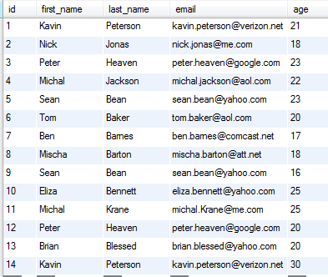

The following SQL query returns the duplicate emails from the contact table:

SELECT email, COUNT(email) FROM contacts GROUP BY email HAVING COUNT(email) > 1;

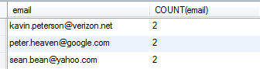

Delete duplicate rows with the DELETE JOIN statement

**DELETE t1 FROM contacts t1**

**INNER JOIN contacts t2**

**WHERE**

**t1.id < t2.id AND**

**t1.email = t2.email;**

Select *from contacts;

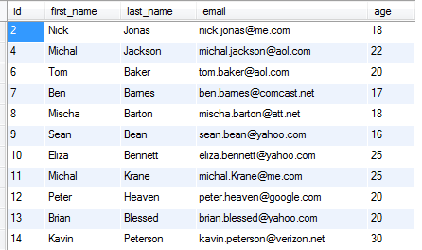

Three rows had been deleted.

**Question 2: Query to print the current date**

**select curdate();**

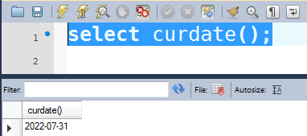

**Question 3: Query to print the current date and time**

**Select now();**

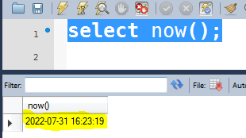

# **Question 4:** [**SQL query to find third highest salary in company**](https://stackoverflow.com/questions/20690629/sql-query-to-find-third-highest-salary-in-company)

**SELECT * FROM employee ORDER BY salary DESC LIMIT 2, 1;**

**Question 5: What is constraint?**

Constraint can be used to specify the limit on the data type of table. Constraint can be specified while creating or altering the table statement. Sample of constraint are.

* NOT NULL.
* CHECK.
* DEFAULT.
* UNIQUE.
* PRIMARY KEY.
* FOREIGN KEY.

Question 6: What are the types of Join

1. Inner Join- The INNER JOIN keyword selects records that have matching values in both tables.
2. Left Join- The LEFT JOIN keyword returns all records from the left table (table1), and the matching records from the right table (table2). The result is 0 records from the right side, if there is no match.
3. Right Join- The RIGHT JOIN keyword returns all records from the right table (table2), and the matching records from the left table (table1). The result is 0 records from the left side, if there is no match.
4. Full Join- The FULL OUTER JOIN keyword returns all records when there is a match in left (table1) or right (table2) table records. **Tip:** FULL OUTER JOIN and FULL JOIN are the same.
5. Self Join- Self-join is set to be query used to compare to itself. This is used to compare values in a column with other values in the same column in the same table. ALIAS ES can be used for the same table comparison.
6. Cross Join- Cross join defines as Cartesian product where number of rows in the first table multiplied by number of rows in the second table. If suppose, WHERE clause is used in cross join then the query will work like an INNER JOIN.

Question 7: What is CLAUSE?

SQL clause is defined to limit the result set by providing condition to the query. This usually filters some rows from the whole set of records.

Example – Query that has WHERE condition

Query that has HAVING condition.

### Question 8: How to select unique records from a table?

### Select unique records from a table by using DISTINCT keyword.

**Select DISTINCT StudentID, StudentName from Student;**

Question 9: Which operator is used in query for pattern matching?

LIKE operator is used for pattern matching, and it can be used as -.

% – Matches zero or more characters.

_(Underscore) – Matching exactly one character.

Example -.

**Select * from Student where studentname like 'a%'**

**Select * from Student where studentname like 'ami_'**

### Questions 10: What are some common clauses used with SELECT query in SQL?

### WHERE clause in SQL is used to filter records that are necessary, based on specific conditions.

* ORDER BY clause in SQL is used to sort the records based on some field(s) in ascending (ASC) or descending order (DESC).
* GROUP BY clause in SQL is used to group records with identical data and can be used in conjunction with some aggregation functions to produce summarized results from the database.
* HAVING clause in SQL is used to filter records in combination with the GROUP BY clause. It is different from WHERE, since the WHERE clause cannot filter aggregated records.

### Questions 11: What is a primary key?

A primary key is a combination of fields which uniquely specify a row. This is a special kind of unique key, and it has implicit NOT NULL constraint. It means, Primary key values cannot be NULL.

### Question 12:  What is a foreign key?

A foreign key is one table which can be related to the primary key of another table. Relationship needs to be created between two tables by referencing foreign key with the primary key of another table.

### Question 13: What is a View?

A View can be defined as a virtual table that contains rows and columns with fields from one or more tables.

Syntax:

|  |
| --- |
| CREATE VIEW view_name AS  SELECT column_name(s)  FROM table_name  WHERE condition |

### Question 14: What is an Index?

An index is performance tuning method of allowing faster retrieval of records from the table. An index creates an entry for each value and it will be faster to retrieve data.

### Question 15: **What is the difference between DELETE and TRUNCATE statements?**

The differences are:

* The basic difference in both is DELETE command is DML command and the TRUNCATE command is DDL.
* DELETE command is used to delete a specific row from the table whereas the TRUNCATE command is used to remove all rows from the table.
* We can use the DELETE command with WHERE clause but cannot use the TRUNCATE command with it.

Question 16: **What is the difference between DROP and TRUNCATE?**

**Answer:**TRUNCATE removes all rows from the table which cannot be retrieved back, DROP removes the entire table from the database and it also cannot be retrieved back.

Question 17: What are the aggregate functions in SQL

* AVG(): Returns the average value from specified columns.
* COUNT(): Returns number of table rows.
* MAX(): Returns the largest value among the records.
* MIN(): Returns smallest value among the records.
* SUM(): Returns the sum of specified column values.

### Question 18: Differentiate: CHAR and VARCHAR data types in SQL?

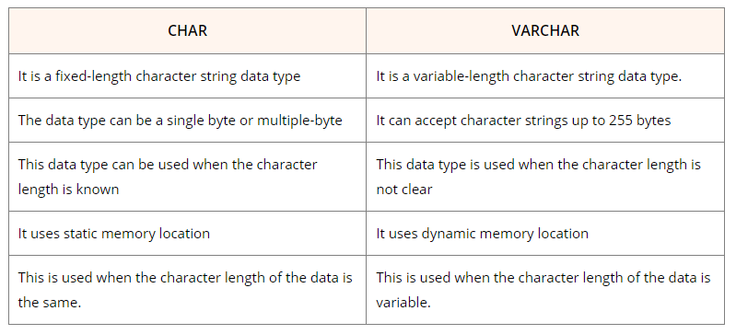

Question 19: What are the types of SQL command

There are five types of SQL commands: DDL, DML, DCL, TCL, and DQL.

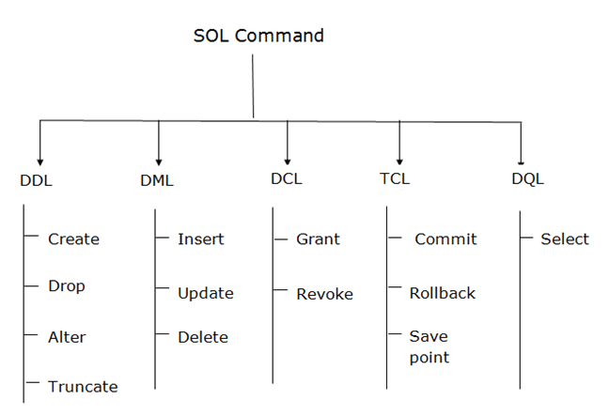

Question 20: How to increase 10% salary of the employee

Now, the Select * from Employee query will display the following result

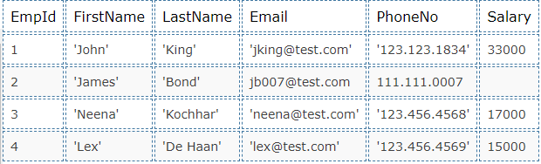

**UPDATE Employee**

**SET Salary = Salary + (Salary * 10/100);**

Now, the Select * from Employee query will display the following result.

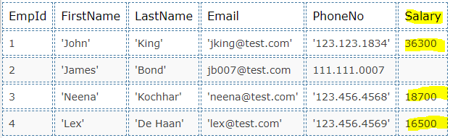

Q21: Join Syntax

